**Creating Microservices for account and loan**

**Account Microservice –**

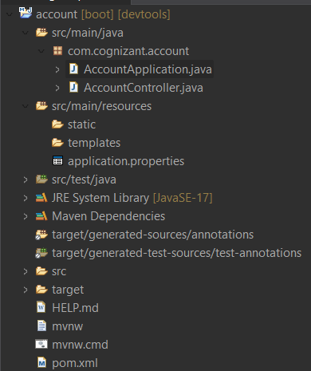

*AccountApplication.java –*

package com.cognizant.account;

import org.springframework.boot.SpringApplication;

import org.springframework.boot.autoconfigure.SpringBootApplication;

@SpringBootApplication

public class AccountApplication {

public static void main(String[] args) {

SpringApplication.run(AccountApplication.class, args);

System.out.println("Running on port 8080");

}

}

*AccountController.java –*

package com.cognizant.account;

import org.springframework.web.bind.annotation.GetMapping;

import org.springframework.web.bind.annotation.PathVariable;

import org.springframework.web.bind.annotation.RestController;

@RestController

public class AccountController {

@GetMapping("/accounts/{number}")

public Response getAccountResponse(@PathVariable String number) {

return new Response(number, "savings", 75000.00);

}

public static class Response{

private String accountNumber;

private String type;

private double balance;

public Response(String accountNumber, String type, double balance) {

super();

this.accountNumber = accountNumber;

this.type = type;

this.balance = balance;

}

public String getAccountNumber() {

return accountNumber;

}

public String getType() {

return type;

}

public double getBalance() {

return balance;

}

}

}

*Pom.xml –*

<?xml version="1.0" encoding="UTF-8"?>

<project xmlns="http://maven.apache.org/POM/4.0.0" xmlns:xsi="http://www.w3.org/2001/XMLSchema-instance"

xsi:schemaLocation="http://maven.apache.org/POM/4.0.0 https://maven.apache.org/xsd/maven-4.0.0.xsd">

<modelVersion>4.0.0</modelVersion>

<parent>

<groupId>org.springframework.boot</groupId>

<artifactId>spring-boot-starter-parent</artifactId>

<version>3.5.3</version>

<relativePath/> <!-- lookup parent from repository -->

</parent>

<groupId>com.cognizant</groupId>

<artifactId>account</artifactId>

<version>0.0.1-SNAPSHOT</version>

<name>account</name>

<description>Demo project for Spring Boot</description>

<url/>

<licenses>

<license/>

</licenses>

<developers>

<developer/>

</developers>

<scm>

<connection/>

<developerConnection/>

<tag/>

<url/>

</scm>

<properties>

<java.version>17</java.version>

</properties>

<dependencies>

<dependency>

<groupId>org.springframework.boot</groupId>

<artifactId>spring-boot-starter-web</artifactId>

</dependency>

<dependency>

<groupId>org.springframework.boot</groupId>

<artifactId>spring-boot-devtools</artifactId>

<scope>runtime</scope>

<optional>true</optional>

</dependency>

<dependency>

<groupId>org.springframework.boot</groupId>

<artifactId>spring-boot-starter-test</artifactId>

<scope>test</scope>

</dependency>

</dependencies>

<build>

<plugins>

<plugin>

<groupId>org.springframework.boot</groupId>

<artifactId>spring-boot-maven-plugin</artifactId>

</plugin>

</plugins>

</build>

</project>

*Application.properties –*

spring.application.name=account

server.port=8080

**Output – (Running on port 8080)**

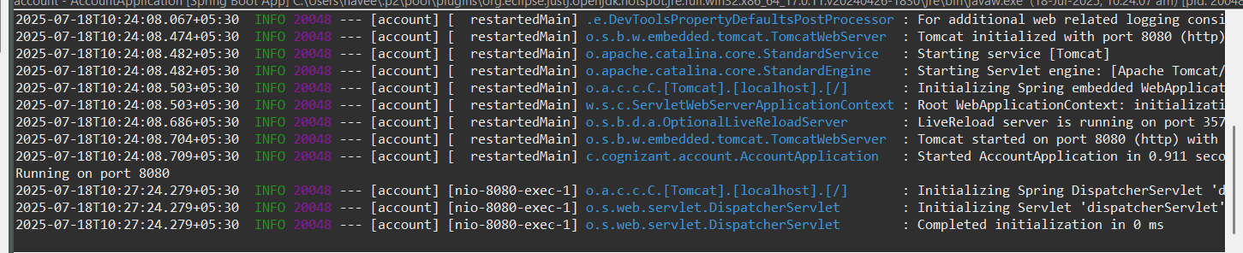

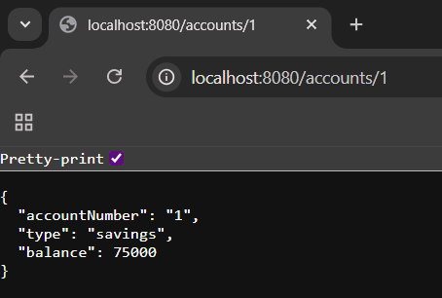

**Loan Microservice –**

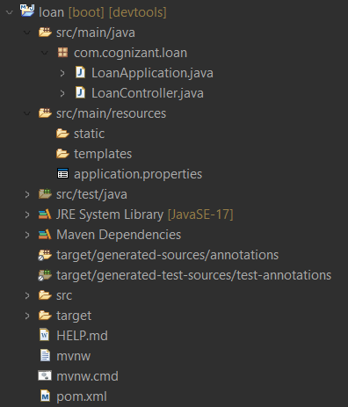

*LoanApplication.java –*

package com.cognizant.loan;

import org.springframework.boot.SpringApplication;

import org.springframework.boot.autoconfigure.SpringBootApplication;

@SpringBootApplication

public class LoanApplication {

public static void main(String[] args) {

SpringApplication.run(LoanApplication.class, args);

System.out.println("Running on port 8081");

}

}

*LoanController.java –*

package com.cognizant.loan;

import org.springframework.web.bind.annotation.GetMapping;

import org.springframework.web.bind.annotation.PathVariable;

import org.springframework.web.bind.annotation.RestController;

*@RestController*

public class LoanController {

*@GetMapping*("/loans/{number}")

public Response getLoanResponse(*@PathVariable* String number) {

return new Response(number, "car", 400000.00, 3250.00, 24);

}

public static class Response{

private String number;

private String type;

private Double loan;

private Double emi;

private Integer tenure;

public Response(String number, String type, Double loan, Double emi, Integer tenure) {

super();

this.number = number;

this.type = type;

this.loan = loan;

this.emi = emi;

this.tenure = tenure;

}

public String getNumber() {

return number;

}

public String getType() {

return type;

}

public Double getLoan() {

return loan;

}

public Double getEmi() {

return emi;

}

public Integer getTenure() {

return tenure;

}

}

}

*Pom.xml –*

<?xml version="1.0" encoding="UTF-8"?>

<project xmlns="http://maven.apache.org/POM/4.0.0" xmlns:xsi="http://www.w3.org/2001/XMLSchema-instance"

xsi:schemaLocation="http://maven.apache.org/POM/4.0.0 https://maven.apache.org/xsd/maven-4.0.0.xsd">

<modelVersion>4.0.0</modelVersion>

<parent>

<groupId>org.springframework.boot</groupId>

<artifactId>spring-boot-starter-parent</artifactId>

<version>3.5.3</version>

<relativePath/> <!-- lookup parent from repository -->

</parent>

<groupId>com.cognizant</groupId>

<artifactId>loan</artifactId>

<version>0.0.1-SNAPSHOT</version>

<name>loan</name>

<description>Demo project for Spring Boot</description>

<url/>

<licenses>

<license/>

</licenses>

<developers>

<developer/>

</developers>

<scm>

<connection/>

<developerConnection/>

<tag/>

<url/>

</scm>

<properties>

<java.version>17</java.version>

</properties>

<dependencies>

<dependency>

<groupId>org.springframework.boot</groupId>

<artifactId>spring-boot-starter-web</artifactId>

</dependency>

<dependency>

<groupId>org.springframework.boot</groupId>

<artifactId>spring-boot-devtools</artifactId>

<scope>runtime</scope>

<optional>true</optional>

</dependency>

<dependency>

<groupId>org.springframework.boot</groupId>

<artifactId>spring-boot-starter-test</artifactId>

<scope>test</scope>

</dependency>

</dependencies>

<build>

<plugins>

<plugin>

<groupId>org.springframework.boot</groupId>

<artifactId>spring-boot-maven-plugin</artifactId>

</plugin>

</plugins>

</build>

</project>

*Application.properties –*

spring.application.name=loan

server.port=8081

**Output – (Running on port 8081)**

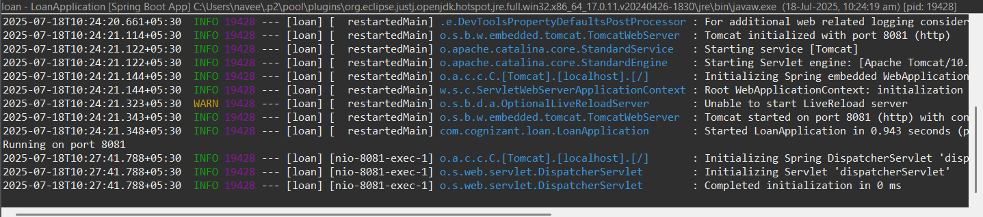

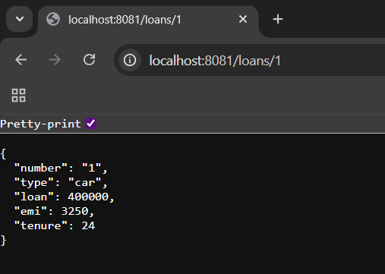

**Note –** Account Microservice is running on port **8080** and Loan Microservice is running on port **8081** simultaneously.